German Shepherd Dog Club of Washington State, Inc

Is offering an All-Breed/Mixed Breed

SANCTION MATCH
Practice for our Specialty!
Conformation (GSDs Only)
All Breed Obedience and Rally
Minimum of 10 dogs per Rally and Obedience each, limit 40
AKC APPROVED

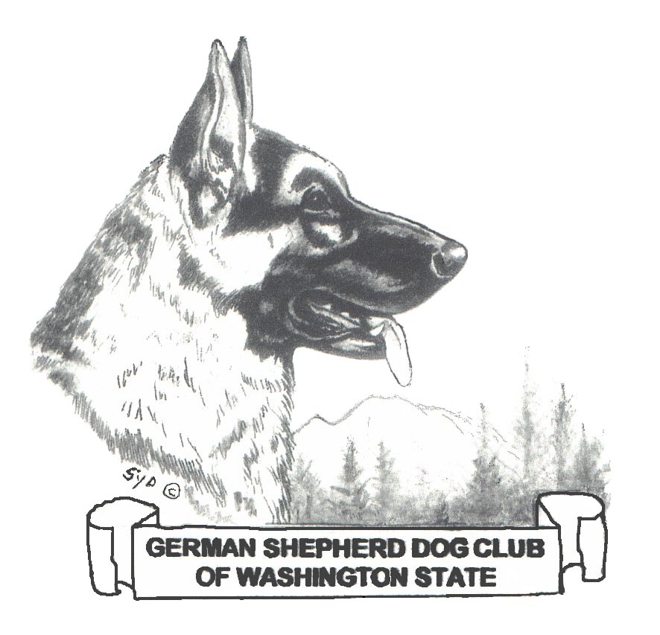

April 18, 2022

Location: RENTON

CARCO PARK, Renton WA
EXIT 4 ON 405

Entry Fee: $10.00. $5.00 for second run same dog
Registration starts at 9:00 - Judging to start at 10:00
Conformation Judge: ___________ /Rally:___________ /Obedience:_______

Registration and Release Form
(Print clearly or type)
I would like to register my dog for….
Conformations GSD only: (circle one) dog or bitch which class: ________________
Beginners Novice ____ Novice ______ Open ____ Utility ____ Graduate Novice ________ Heights__________
Graduate Open ________ Pre-Novice _________ Pre-Open _________ Pre-Utility___________

Rally Novice ______Intermediate_______ advanced ________excellent ______ Master_______ height __________

Dog’s Name__________________________________________________ CALL NAME: ________________________
Breed
Owner
Address
Phone Email:

Signature of Entrant(s)_______________________________________________________________________________________

Phone Number_______________________________________________Date_________________________________________

Release Form
In consideration for participation in the Sanction Match held by the German Shepherd Dog Club of Washington State Inc , I (we) agree to assume all responsibility for any claim, loss, or damage, of whatever kind or nature, whether to person or property, which may be caused at or near this Sanction Match, I (we) further agree that I (we) will hold the GSDCWS, its officers, directors, agents and members harmless and defend them from any and all liability for any injury, claim, damage or loss, of whatever kind or nature, whether to person or property, caused at or near this Sanction Match I (we) agree to indemnify the GSDCWS, its officers, directors, agents and/or members for any loss, cost, or expenses, including attorney fees and costs, in which the GSDCWS, its officers, directors, agents or members might be subject as a result of any claim, suit, loss or damage caused in any way by any act or negligence on my part or on the part of any dog or dogs I (we) have entered or brought to the Sanction Match, I(we) acknowledge that while the GSDCWS may provide for this Sanction Match, does not have and does not exercise control over the conduct of those present. I (we) certify and represent that the dog or dogs I (we) have entered or brought to this Sanction Match is/are not a hazard to other dogs, other animals or to people.

MAKE CHECK PAYABLE TO: GSDCWS C/O Kerry Southern 16509 245th St E Graham, WA 98338
pre-entries due by April 11, 2021

