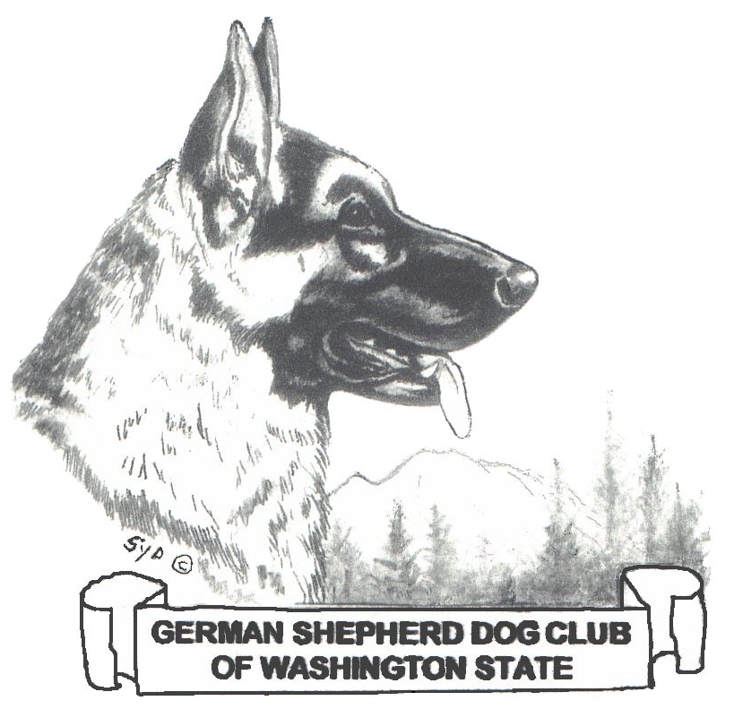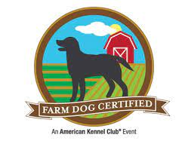

German Shepherd Dog Club of Washington State
Farm Dog Certified Test
Golden Willow Ranch
20110 Patterson Rd East
Orting, WA 98360
August 5, 2023
All entries taken in the order received until judges’ slots are filled.
Pre registration closes July 28, 2023 .

Farm Dog Certified (FDC) Fee per test: $30.00 pre-registration, $35.00 day of entry.
Event number: 2023109609
Judges:
Laura Cronin, 20110 Patterson Rd E, Orting WA 98360
Rebecca K Lohse, 19605 184TH ST E, Orting, WA 98360
Limit of 25 FDC tests per judge. Tests may use sheep or ducks as livestock. Tests may run simultaneously under different judges in different areas of the farm.

Check in: 9:30 am. Start time: Test 1: 10:30. Test 2: 10:45.
On-site entries, if available, closes at 10:20 AM.
Mail entries and check for entry fee to: Test Secretary, Erika Brennan, 16603 35th Avenue South, Seatac WA 98188. Make Checks payable to: GSDCWS
OR e-mail entry to erikabee1123@gmail.com & pay via paypal to: GSDCWS2019@comcast.net
---------------------------------------------------------------------------------------------------------------------
Entry Form (one entry form per dog) Check all that apply: Test 1: _______ Test 2: ________
Dog Name: ______________________________________________
AKC# ______________________________ Breed: _________________________________
Owner Name____________________________________________ Phone_________________ Address_______________________________________________Email____________________
Amount enclosed: ________________
Please Sign the back page, entries that are not signed are not valid.
Hold Harmless Agreement:

I certify that I am the actual owner of the dog, or that I am the duly authorized agent of the actual owner whose name I have entered above in consideration of the acceptance of this entry. I agree that the organization holding this event has the right to refuse this entry for cause which the organization shall deem to be sufficient. In consideration of this entry, I agree to hold this organization and Golden Willow Ranch and/or its members, directors, officers, agents and any employee of the aforementioned parties, harmless from any claim for loss or injury which may be alleged to have been caused directly or indirectly to any person or thing by the act of this dog while in or upon the event's premises or grounds or near any entrance thereto, and I shall personally assume all responsibility and liability for any such claim; and I further agree to hold the aforementioned parties harmless from any claim for loss of this dog by disappearance, theft, death or otherwise, and from any claim for damage or injury to the dog, whether such loss, disappearance, theft, damage or injury be caused or alleged to be caused by the negligence of this organization or any of the aforementioned parties, or by the negligence of any other person, or any other cause or causes. I certify and represent that this dog entered is not a hazard to persons or other dogs. By my signature below, I accept the foregoing representation and agreement. Additionally, I will pay for any injuries or the replacement value in the event of serious injury to the livestock caused by my dog. I hereby agree that the determination of whether the injury is serious shall be made by the owner of the livestock and is binding on me.

Signature: ____________________________________________________Date: ____________

